DBMS

LAB ASSIGNMENT - 8



Ananya Agarwal

102083036

2CO14

Data:

create table SalesPeople

(Snum number primary key,

Sname varchar2(10) unique,

City varchar2(20),

Comm number(5,2)

);

insert into SalesPeople values(1001,'Peel','London',0.12);

insert into SalesPeople values(1002,'Serres','Sanjose',0.13);

insert into SalesPeople values(1004,'Motika','London',0.11);

insert into SalesPeople values(1007,'Rifkin','Barcelona',0.15);

insert into SalesPeople values(1003,'Axelrod','Newyork',0.10);

create table Customers

(Cnum number primary key,

Cname varchar2(10),

City varchar2(10) not null,

Snum number(5) references SalesPeople(Snum));

insert into Customers values(2001,'Hoffman','London',1001);

insert into Customers values(2002,'Giovanni','Rome',1003);

insert into Customers values(2003,'Liu','Sanjose',1002);

insert into Customers values(2004,'Grass','Berlin',1002);

insert into Customers values(2006,'Clemens','London',1001);

insert into Customers values(2008,'Cisneros','Sanjose',1007);

insert into Customers values(2007,'Pereira','Rome',1004);

create table Orders

(Onum number primary key,

Amt number(10,2),

Odate date,

Cnum number(5) references Customers(Cnum),

Snum number(5) references SalesPeople(Snum)

);

insert into Orders values(3001,18.69,to_date('3-10-1990','dd-mm-yyyy'),2008,1007);

insert into Orders values(3003,767.19,to_date('3-10-1990','dd-mm-yyyy'),2001,1001);

insert into Orders values(3002,1900.10,to_date('3-10-1990','dd-mm-yyyy'),2007,1004);

insert into Orders values(3005,5160.45,to_date('3-10-1990','dd-mm-yyyy'),2003,1002);

insert into Orders values(3006,1098.16,to_date('3-10-1990','dd-mm-yyyy'),2008,1007);

insert into Orders values(3009,1713.23,to_date('4-10-1990','dd-mm-yyyy'),2002,1003);

insert into Orders values(3007,75.75,to_date('4-10-1990','dd-mm-yyyy'),2004,1002);

insert into Orders values(3008,4273.00,to_date('5-10-1990','dd-mm-yyyy'),2006,1001);

insert into Orders values(3010,1309.95,to_date('6-10-1990','dd-mm-yyyy'),2004,1002);

insert into Orders values(3011,9891.88,to_date('6-10-1990','dd-mm-yyyy'),2006,1001);

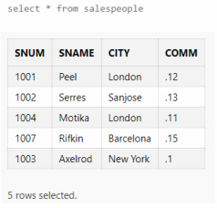

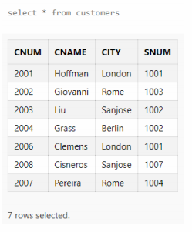

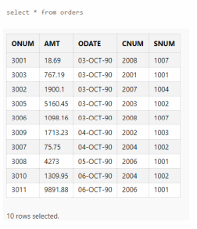

1-Find those salesperson name who live in any one of the city of customers (do it both with sub-query and join)

Select distinct sname from salespeople s, customers c where s.city = c.city;

Select distinct sname from salespeople where city in (select city from customers);

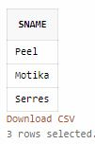

2-Find those salesperson name,customers name who belong to any one of the city of customers (do it both with sub-query and join)

Select distinct (sname,cname) from salespeople s, customers c where s.city = c.city;

No subquery possible

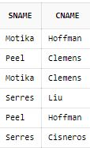

3-Find those salesperson name who belong to the city of their customer (do it both with sub-query and join)

Select distinct sname from salespeople s, customers c where s.city = c.city and s.snum=c.snum;

Select distinct sname from salespeople where (snum,city) in (select snum,city from customers);

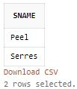

4-Find those salesperson name who belong to the city of their customer (do it with co-related sub-query)

Select sname from salespeople s where exists (select * from customers c where c.snum=s.snum and c.city=s.city);

Select sname from salespeople s where city in (select city from customers where snum=s.snum);

C:\Users\User\Desktop\4.PNG

5-Find those salesperson name, customer name where salesperson is assigned/not assigned to any customer

Select sname,cname from salespeople s,customers c where s.snum=c.snum(+);

select sname, cname from salespeople s left join customers c on s.snum=c.snum;

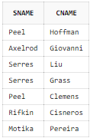

6-Find those customer name who is not assigned to any salesperson

Select cname from customers where snum is null;

C:\Users\User\Desktop\6.PNG

7-Find the highest order of each salesperson

Select snum,max(amt) from orders group by snum;

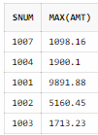

Select * from orders where amt in (select max(amt) from orders group by snum));

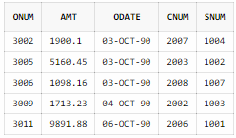

8-Find the names of salesperson and their highest order

Select sname,max(amt) from salespeople s,orders o where s.snum=o.snum group by s.snum,sname;

Select s.sname, o.amt from salespeople s, orders o where amt in (select max(amt) from orders group by snum) and s.snum=o.snum;

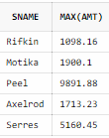

9-Find those orders of salesperson which is more than his average orders

*This query can be done only through co-related subquery*

Select onum,snum,amt from orders o where amt > (select avg(amt) from orders where o.snum = snum);

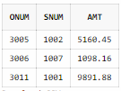

10-List those salesperson who has more than two customers. (use all 3 methods)

Join:

Select sname from salespeople s, customers c where s.snum=c.snum group by sname having count(c.snum) > 2;

Simple subquery:

Select * from salespeople where snum in (select snum from customers group by snum having count(snum) > 2);

Co-related subquery:

Select * from salespeople s where 2 < (select count(c.snum) from customers c where c.snum=s.snum);

C:\Users\User\Desktop\10.PNG